From the outside looking in: the risk, the money, & the public:
UK Geothermal

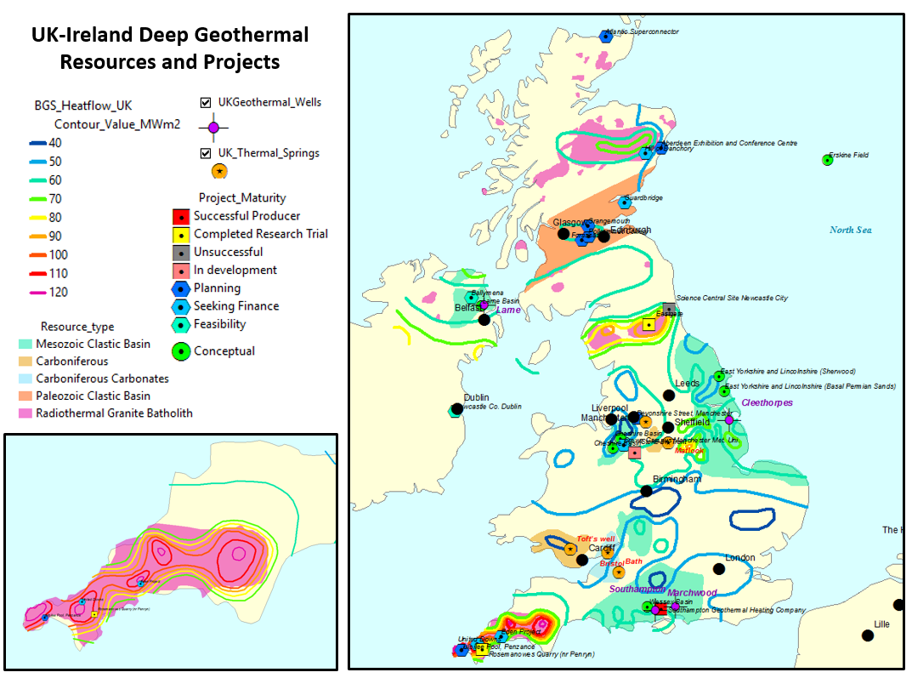
Paetoro is in the process of compiling geothermal resource data and information about historically proposed geothermal projects within the UK and Ireland.
The above info is modified after BGS and public domain web sources.

UK Geothermal?

In the UK, the size of the geothermal prize is far from obvious – a few mildly warm springs in Bath and one or two elsewhere. Not a huge clue to the un-initiated.

In reviewing the subject, what is striking is the number of projects that have been attempted or suggested over the years (see map), with some limited success. There has been a lot of excellent work done. BGS has done a huge amount and their website (http://www.bgs.ac.uk/research/energy/geothermal/) and a summary report (http://shop.bgs.ac.uk/Bookshop/product.cfm?p_id=GEOM1A) (the latter for £20) are great places to start, as is the description of the BritGeothermal Consortium (http://www.bgs.ac.uk/research/energy/geothermal/britGeothermal.html ). The DECC 2013 study is also a good piece of work and highly informative about the perceived issues at that time (https://www.gov.uk/government/publications/deep-geothermal-review-study ).

In many ways it feels like much of the broad geology has already been done – it’s now down to the detail.
Anglia erupting

Sometime in the mid-1970’s, at the viewpoint overlooking Wairakei Geothermal Power Station in New Zealand, a Ford Anglia’s radiator erupted in magnificent empathy with the surrounding valley. The steam pouring from the raised bonnet amongst a valley of cooling towers doing the same thing was an amusing if frustrating spectacle to the surrounding family. Some primordial sentiment in the engineering of a Ford Anglia synched with the wonder of Wairakei geothermal valley. Talk about artificial intelligence. But then “Ford Angulars” always were ahead of their time. I was there, and thanks to the family car, geothermal has been indelibly etched in my consciousness ever since .

They don’t make ‘em like that anymore

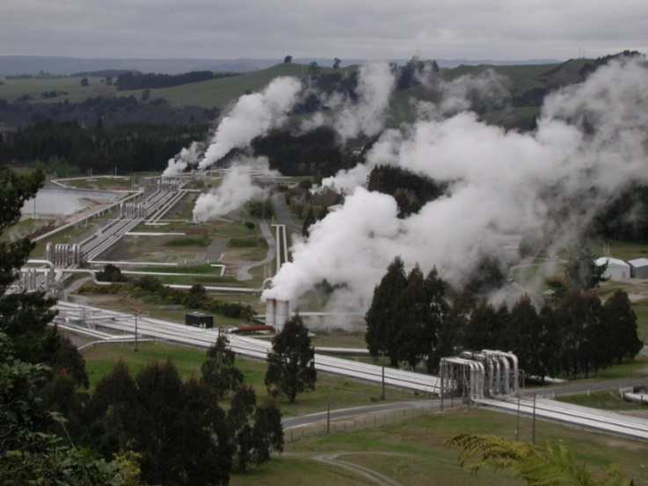
They needn’t make ‘em like that anymore.

Wairakei’s (literally) ground-breaking geothermal plant in New Zealand was one of the world’s first – built in 1958, and sits atop one of the highest heat flows on the planet. Technology means such obvious areas of heat flow are no longer a pre-requisite for harnessing geothermal heat.

Touring the geothermal areas of NZ, or other similar areas of the globe, the potential for energy is obvious – who can fail to see the energy involved in an erupting geyser. But UK? Seriously?

Between the thermonuclear explosion and seething molten furnace

It is rather ironic that mankind talks of an energy shortage when here we are nestled between the sun – a blazing sustained thermonuclear explosion contained only by gravity, and a planet that is 99.9% above the boiling temperature of water. Only the tiny thickness of skin at the surface is otherwise. Any aliens out there must be thinking us pretty thick not to make use of it more.

This however, is now a bit of a cliché - in truth it is to trivialise the problem. The catch is we depend on pumping lots of fluid through the ground to recover that heat, then pumping it round heat exchangers - and it takes energy to do so. The deeper it goes, the more energy (and money) it takes to get it back. The freezing wastes of space tickling the planet’s surface are a big sponge we do battle with, to “net” the heat efficiently.

It’s also worth noting that in the strict sense, geothermal is not an infinite resource because injecting cool water into lower heat flow areas does cool the ground down ever slightly & ever so slowly. The continual resupply of heat from the earth’s interior, or from the sun in the top 15m - means this effect is often negligible – certainly over the lifespan of a project. Not always though – it can impose limits on the rates of hot water extraction, depending on the permeabilities.

Milking the metal

Engineering technology is always moving ahead steadily. The concepts of heat exchange are not new ones, but the efficiency of its implementation is. Ground sourced heat pumps for shallow geothermal are capable of harvesting heat from differences of just a few degrees. They do the same job as a fridge essentially – taking heat from one place and putting it in another, but making use of the heat instead of releasing it into the surroundings. They also retain the option of storing the cold as a potential useful by-product for air-con etc. Check out companies like GroundSun (www.groundsun.com) in London – doing this as we speak.

Other advances in geothermal are encouraging too. Exnics in Scotland have developed “hot rings” that can allow offshore and onshore drilling operations for hydrocarbons to extract energy from subsurface warmed fluids (http://www.exnics.com/ ).

A group of students from MIT are looking into the feasibility of geothermal from newly abandoned oil wells in the US and Canada:
(https://static1.squarespace.com/static/57127fda86db434acc69a4db/t/58e5d6f01e5b6c57a9e7c389/1491457810144/Eden.pdf).

What about abandoned wells? There are abandoned wells and abandoned wells, and deciphering historical well information isn’t trivial work. Re-accessing them can sometimes be just as hard and harder as drilling new ones, and full of HSE questions. Making the best of new ones, or active ones just about to be abandoned is an easier proposition. That said, with the number of past wells that exists around the world, there are likely some “low hanging fruit” for previous wells also.

The engineering ideas, suffice to say, are coming in thick and fast. Some are proven, some less so, some are incremental advances, some totally new - but the gist is clear – we can harness heat in the ground and we can harness heat in water. We can use heat exchangers and fluids to extract the energy and produce heating and cooling, from relatively small elevations in temperature – as long as the heat source is big.

Yes, seriously…

These advances mean you don’t need a Yellowstone style geyser to make use of geothermal energy. Anywhere that you have a hole in the ground that can give you warmer water – you have some potential – hence the rapidly expanding market in heat pumps (http://www.heatpumps.org.uk/ ). This is an idea whose time has come. It is startling though how poor public awareness of this resource remains:
https://www.gov.uk/government/uploads/system/uploads/attachment_data/file/611985/Summary_of_key_findings_BEIS_Public_Attitudes_Tracker_-_wave_21.pdf )

Going deeper for geothermal energy is a slightly different proposition. The warmer the rocks the better of course, but there is a trade-off between temperature, depth, and drilling cost. We do have some warm rocks in in the UK. Granites and Paleozoic and Mesozoic sandstone aquifers provide the best potential resources for moderately deep geothermal, and some places (e.g. Southampton) are already utilising these. It’s not an unproven concept.

Of these, the granites are geologically riskier and somewhat trickier from a permeability perspective, even though they typically have more heat. This probably makes aquifers the preferable place to start, since so much of the commerciality of geothermal depends on volume, and the actual temperature is less critical for harnessing energy these days. Also, to get the best out of granites can involve contemplating fracking – which rightly or wrongly won’t always go down well, and adds another layer of social licence complexity.

Deep aquifers aren’t without issue either – the Mesozoic reservoirs with the best potential permeabilities in the UK don’t tend to get deep enough to reach temperatures much above 60 deg C. That makes the economics more difficult – typically something > 80 deg C is desirable to really justify deep drilling costs. Efficiencies and costs are frequently on the improve though, and as economics of scale kick in costs come down even more – so the Permo-Triassic sands will be one to watch. District heating schemes could conceivably work from 60 degrees – which means about 2 km depth in the UK.

Schemes from lower temperatures are technically feasible but require heat pump technologies to elevate the temperature. Heat pumps aren’t magic, they require energy themselves and so impact the economics, but as these become cheaper and more efficient lower temperature heat sources can be thought of more readily.

Abandoned coal mines filled with water are another potential source – making use of holes in the ground that exist already – so no drilling costs to hit the economics - and Town Rock Energy (http://townrockenergy.com/ ) amongst others, is making great strides there.

Overall, there is a growing number of UK & Ireland based companies looking at both shallow and deep geothermal in the UK and overseas, each with slightly different expertise. With apologies to any I have left out, they include:

- Cluff Geothermal (London)
- DEEPEGS
- Drilcorp Ltd
- EGS Energy
- Exnics
- Geo-Drill Limited
- Geothermal Engineering Ltd
- GeoScience Ltd.
- Geon Energy
- GT Energy (Ireland)
- Teckna Group
- Town Rock Energy

Other advances in electricity transmission and storage will also expand options – witness the ambitious Atlantic Superconnection project (http://www.atlanticsuperconnection.com/ ) that is hoping to bring geothermal energy from Iceland to the UK grid. This might not be the cheapest option, but it would be the option that provided the largest amount of electricity generated from geothermal. Can it compete with other renewables? The race is on to find out.

There are so many projects of so many different forms, to an outsider it can seem a bit of tribal environment out there – with each tribe singing the merits of their own resource and warning of the difficulties of their competitors! Deep geothermal versus shallow. Granites versus deep aquifers and flooded coal mines. Temperature versus water volume. Pure geothermal versus piggy backing off mining or hydrocarbons. Imports from Iceland.

The “winner” that proves itself most efficient value for money wise, may dominate for a long time - or it may be that one size doesn’t fit all and different things are best for different places, with diversity providing energy security. The scale of the resource provided and the cost to reap it will dictate the winners and losers. For now, it seems wisest to encourage firing on all cylinders - experimenting with many and getting more feel for which works best - but there is a need to start somewhere – and that should be done carefully.

Riding the risk. Eggs. Baskets.

The geology and the engineering are not without issues. There is geological risk – not every project works. Typically, this relates to problems with permeability – the ability to deliver and retrieve sufficient volumes of warm water to make money. So just like oil exploration, some projects will work and some won’t. While geoscientists will do all they can to estimate risk and pick the sweet spots – they can never fully eliminate the risk. As with oil though, in theory, if you have enough successes in your portfolio, they can absorb the costs of any failures. They key word there though, is portfolio.

Technical issues aren’t the only problem. It’s startling to an outsider how many UK geothermal projects have stalled at the funding stage. Raising of the money appears the biggest project killer. Of course, the risk and difficulty in raising money are not unrelated – but is it technical logic or that most hard-wired of human responses - fear of the unknown - that is the real block? Until there are more working examples, it will be a bit of a mixture of both.

I might be missing something, but maybe this barrier isn’t too hard to understand. The most likely clients for such projects are councils wanting to heat suburbs, or industrial estates, or big organisations like schools or universities, or large shopping or sports centres. It is admirable that some of these have already invested a lot of time, effort, and expense in the testing of geothermal projects, typically in conjunction with Government or University Research projects. Some have worked, some haven’t – with poor permeability typically the key cause of failure. Therein lies the rub – geological risk is not something that sits easily with a council or a hospital. Drilling is not cheap and the costs of a failed project are a big hit for such organisations to take.

The competition

Putting aside the risks for a second, and assuming we do find a viable geothermal reservoir - solar and other renewable energies are also taking off – so how does geothermal compare? These are the competition it has to better.

Geothermal doesn’t tend to look that great if you graph efficiency of electricity generation:
(http://www.mpoweruk.com/energy_efficiency.htm ),
but this ignores the additional benefits of using the heat, also - the sheer size of the resource also means the efficiency is less of a problem.

If you have a very restricted resource, of course you want to extract energy from it most efficiently – but if you have a huge reservoir of heat, then efficiency is less of a concern. As an example - If you have a huge lake of water, you wouldn’t worry too much about using a slightly leaky cup as you took a drink from it. If however you only had a bottle of water to last you a week – you would worry about the efficiency of your vessel a great deal more. With geothermal, we have a lake.

Given the advances in wind and solar though, there is a real efficiency question when it comes to making electricity – on a large scale they can generate electricity more efficiently – so the real advantage with geothermal comes with water heating, rather than the gas driven turbines required to make electricity. Historically this required steam and hence temperatures greater than 100 degrees C.

With modern heat pumps, we can use heat exchangers to boil water from originally warm water, but each iteration of heat exchange takes energy, lowers the efficiency, and increases the expense, so it is difficult to compete with alternative methods unless you have lots of cheap genuinely very hot water. With new generation binary geothermal plants using fluids other than water, they don’t need to be 100 degrees C any more, but they do need to be a decent 80 or 90 deg. C for electricity generation to be practical.

So, in a nutshell, when we are not exploring in areas like Iceland or Yellowstone, or Rotorua, in areas where steam is not a given – it is the hot water that drives the commerciality of the geothermal projects. Any electricity you get out of sufficiently hot water is a bonus and not the main driver. This has important implications – mainly the need to find markets for hot water close-by.

You take the high road…

In this commercial context, there are only two options really – either
- The geothermal industry clubs together and takes a portfolio approach, with the rewards of successful projects covering the failures, as in oil exploration, or
- The geothermal industry focusses on projects that somehow dramatically reduce the risk.

Option 1: It’s the money mister…

Successful application of UK geothermal might simply be a case of finding the right investment vehicle to get a sizeable portfolio of projects going, with economies of scale, so that any failures can be absorbed in the successes, and costs can be shared and minimised across projects. In this approach clients can be protected somewhat from the costs of a failed project. Government subsidy might be an option initially to help with that, but a far-sighted corporation - able to take the odd hit to capture all the successes - would be a better one. Taxpayers are wary of subsidising things, so for an idea to really fly long term, it needs to work independent of handouts – otherwise it will always be hostage to political fortunes.

Maybe in the long term it will take a larger umbrella organisation that is comfortable with geological risk to move forward. It can do the calculations and satisfy itself that X/Y projects being successful will be enough to make money, and that X/Y chance of success is feasible. Yes, a Shell, BP, E.ON, RWE, Idemitsu, ENEL, Glencore, or BHP, - a big company, maybe with experience of geothermal elsewhere, but not necessarily so. Or maybe a big new peel off from geothermal wings of several companies.

The problem is that there just isn’t enough data kicking around at the minute, from projects in the UK or analogous to the UK, for companies to meaningfully calculate that chance of success X/Y. So, what next?

Option 2: Or is it just about being clever…

The contrasting and probably more appealing approach is to forget large portfolios of expensive geothermal projects of which only a sample will succeed, and to focus on projects that really do maximise the chance of success.

One way to do this is to target areas where two resources can be gone for – e.g. mining targets involving granite plutons, or areas of onshore hydrocarbon exploration where a water wet “failure case” has the potential to be a geothermal “success case”. In the latter case both success cases are starting off seeking the same thing really – a decent thickness of permeable reservoir – so the synergies are very strong actually.

This again, is not a new idea, but never before have the technologies and incentives to try and make it work been so strong. Even if the HC exploration is not a success in its own right, there may be opportunity to boost the geothermal economics by recovering any solution hydrocarbons. Even if the geothermal exploration doesn’t work, the hole can still provide energy for any ongoing activities at the rig-site.

The issue in the UK is that onshore oil & gas prospective areas here don’t (yet) tend to have the combination of temperatures, permeabilities or thicknesses that are economic on their own for geothermal. Permo-Triassic sandstones have the thickness and the perm., but estimates of temperature aren’t quite hot enough onshore at up to ~60 deg. C max. They might just work, but it’s no “slam-dunk”. They can be utilised as a by-product, but don’t have enough oomph to get people very excited as a standalone resource – not yet anyway. The Devono-Carboniferous sandstones are deeper and have something more like the estimated temperatures we need – up to 80-100 deg. C, but so far don’t appear to have the thicknesses or perm except in very localised & difficult to predict areas.

Perhaps it is a case of looking harder. It is early days, and if a case can be made for deepening an oil and gas well to investigate the Mesozoic & Paleozoic reservoirs for geothermal, it is a scenario worth checking out – but it has to be considered carefully on a case by case, play by play, prospect by prospect basis.

Fracking, Frickling, and the public

We see then that in the UK there are two main deep geothermal options for water in the appropriate temperature bracket – granites and deep buried sandstones of Mesozoic or Paleozoic age. Ideally what you want is to be able to inject water in one well and bring up the hot water in the other – this of course requires a permeable pathway between them. There are ways of doing it with just one well but this dramatically decreases the amount of contact time between the water you inject and the hot rock, hence the volumes of water you can heat, and hence the economic viability.

Granites are the hotter of the two options because of the radiogenic material with them, but they can lack extensive natural permeability and extracting geothermal energy from such rocks is sometimes known as “hot dry rock”. In granites without naturally open fractures – it can mean fracking is required to make geothermal work – although this is most usually to open up existing fractures rather than needing to hydraulically crack new ones.

One can reasonably argue that fracturing for geothermal (engineered geothermal systems or EGS) is less of an issue than fracking for hydrocarbons – It’s kind of a fracking-lite – I’m tempted to call it “frickling” – tickling the rock into opening its fractures. There is no risk of hydrocarbons getting places they shouldn’t. It is nevertheless fracking with use of some chemicals and associated well documented issues of induced minor seismicity, and no amount of re-branding is going to hide that truth, nor should it be hidden.

The risks of fracking induced seismicity are not large. Many parts of the world with far lower building standards that the UK see much larger earthquakes on virtually a daily basis. Induced seismicity might typically have a magnitude something like 1.8. A really large induced earthquake might have something like magnitude 3.8. Central New Zealand just survived, while not totally unscathed, a magnitude 7.8. A magnitude 7.8 has 810 thousand times as much energy as a 3.8 (30 to the power of 4), and 729 million times (30 to the power of 6) as much energy as a 1.8. That’s not to belittle the issue - if your house is sitting on top of a very shallow magnitude 2 earthquake, you’ll probably notice it. But your house won’t collapse, and the rarity of such felt seismic events and any related damage means any company would be prepared to insure and compensate.

Rightly or wrongly – without a detailed discussion on the merits of fracking – what we do know is that it doesn’t go down too well with the UK public right now, and no-one is looking for a fight on top of all the other risks, not for hot water anyway. Granite fracking is not without significant cost itself, is frequently unpredictable, and success is needed for the project to work. This kind of project does then have more risk geologically, commercially, and socially.

There are also not very many industrial scale good working case studies yet to offer comfort, though France, Germany, and Australia are amongst those progressing the technology in their own projects. That said, the Eden project is at an advanced stage and will hopefully provide proof on concept in UK eventually (http://www.edenproject.com/eden-story/behind-the-scenes/eden-deep-geothermal-energy-project#60BioR33jPXztzUu.97 ).

I’m not wanting to offend all those worthwhile granite exploitation projects, but there is clearly an extra element of risk involved with granite geothermal exploitation. The reward is higher temperatures, but is that a better reward than higher water volumes?

Hence if one had to choose for larger scale projects, it would seem simpler to target deep sedimentary basins initially, rather than granites, looking for the natural permeabilities that already exist with sands. The temperatures might not be as great, but this is less of an engineering issue than it used to be, and the increased chance of large volume delivery is a much bigger prize than the higher temperature – it delivers more heat, even if the temperature isn’t as high. If we are also to accept that geothermal electricity generation for now is not competitive with renewables in the UK, then we are looking for such basins where there are also large industrial or commercial clients seeking a hot water supply.

Looking familiar

Ignoring for a moment that lower temperature reservoirs might work with heat pump technologies, to maximise the geological and commercial chance of success and to minimise the social objections, we want to target deep thick sandstones at about 80-90 degrees C minimum (implying about 3.0-4.0 km depth in most of the UK), that have enough thickness (~100 m) and natural permeability (>50 mD) to allow movement of commercial amounts of hot water from an injector to a producer, without requiring fracking. A decent seal is also desirable, to prevent downward influx of cooler water. Is this feasible? It seems worth finding out.

As a petroleum geologist, this is remarkably similar to looking for oil and gas reservoirs, except we don’t need a structure or trap filled with hydrocarbons - we just need the warm reservoir with permeability. The difficulty is that to get hot, we want to go as deep as possible, and the deeper you go, generally the permeability decreases while cost increases. That’s the bad news. If there was also prospectivity for commercial geothermal resources in some of the in the UK conventional oil and gas basins (HC reservoirs that don’t need fracking), that would be good news for testing the concept and building the database. It would enable both industries to give each other a “leg-up”. But this is yet to be proven in UK.

Two birds, one (and a half) stones

I know it’s not that easy, if it were people would be dong more of it. Sandstone reservoirs from that depth, thick enough with good permeability are not two-a-penny. When they do exist, figuring out how extensive they are is not easy. But if you are looking for them anyway, to find oil or gas onshore, checking out the geothermal potential as well may increasingly become a no-brainer. If you are going to explore for one resource, and you can also explore for another, why not?

The concept is a simple one – the chances of commercial success increase, and the cost of technical failure for one objective decreases, if you target the two different resources with the one well. It might require a bit of extra expense, like a bit of slim-hole deepening past the most attractive oil and gas reservoirs, but this seems not a huge problem if you do your economics right on a case by case basis.

DECC, in their good 2013 report, indirectly concluded that given a lack of encouraging data from the deep basins, and a lack of investors willing to take the risk, deep geothermal in the UK was unlikely to progress. A bit of data from some of the deep basins could change that quickly though, and if it happened on the back of an oil well, it might not cost that much per se to get that new data. We might also be assisted by innovations and data collection occurring in nearby Europe.

European trailblazing…

Brexit or not, a dedicated European geothermal company tackling portfolios of projects in the UK, Benelux, France and Germany may be a medium to long term achievable ideal – but is probably unlikely in the short term. For now, the need seems to be to target the lowest risk deep sedimentary targets in areas where there are large industrial clients to take the heat. In some locations, it may be possible to lower risk even further by piggy-backing the geothermal exploration on the back of onshore hydrocarbon exploration, either with wells exploring for both, or by using knowledge from oil exploration to target geothermal exploration.

Companies like Trias-Westland in Netherlands, in conjunction with their partners, are leading the way on this and doing it, with a new drilling project as announced on the 10th of May this year:
(http://www.triaswestland.nl/nieuws/startschot-realisatie-trias-westland-gegeven ).
Things are made easier there, due to the greater depth & temperature of decent Permo-Triassic sandstones – at around 3.5-4km. As a rule of thumb, at least 100 m thickness with at least 50 mD is required. Finding that in the UK, if indeed it exists, will probably require sands older than Permo-Triassic, with implications for facies and permeability complexity.

The psychology thing

Companies like focus, and oil & gas companies are wary of diluting focus to do geothermal as well. Yet it’s not that different. It wouldn’t take long to skill-up on the expertise front. It seems an option worth considering – not least because it could work, could save money, and could make money, and a bit of “green” renewable energy PR would do any harm in the bargain.

I suspect a real bust – is the psychology of it all. A hypothetical geoscientist in an oil company going to management with the concept of making money out of the water – well it’s not hard to imagine the reaction. In most settings, it wouldn’t be seen as a career advancing move…to say the least.

Where Paetoro sees an opportunity is in combined play mapping, to show onshore areas where a geothermal – oil & gas combination (and/or mining) might be possible. This gives geoscientists and managements for whom geothermal is a new concept – an initial sense of where it might make sense to investigate further – or not.

Another thing that will help is delineation of markets for the hot water and rigorous economic case studies. This will help people understand more clearly how it can work in pounds and pence bottom lines, and make any proposals seem less Alice-in-Wonderland.

These geological and commercial “play” maps and a diversity of case studies are not fully developed here in the UK yet, though BGS has done a lot of the basic groundwork to enable it. Putting more flesh on the existing bones will continue, and further examples & economic case studies provided by projects elsewhere in the world, will keep coming.

Geothermal doesn’t have to be big to be beautiful
Baby hot spring, Waiotapu NZ
When it grows up it will be a volcano.
Paetoro Plans

At Paetoro, I am researching past geothermal project proposals, and the geology of Mesozoic and Paleozoic basins, simply to find those areas of most promise in the UK and elsewhere in Europe. Those areas where HC and geothermal plays and prospects exist and overlap, with areas of industrial or commercial clients.

Sure, trying to keep fingers in multiple pies takes a bit of extra effort, but it may not be as hard as we think. Trying to get our heads around disciplines less familiar to us, is not without investment of time, but given the synergies that exist, it is not such a big barrier really. Is it worth it? Only time will tell, but on the shoulders of many who have gone before, it does feel like the right time to give the geothermal dice another shake.

It doesn’t mean that geothermal is the right thing to do – that’s not a given - there are technical and commercial risks meaning through case by case analysis is required. It does mean though, that’s it not stupid to consider it.

